CPRA PROJECT TOUR INFORMATION
Acadiana Regional Airport Street Improvements – Admiral Doyle Drive (TV-0031)

Where it's at
This project is on Admiral Doyle Drive in Iberia Parish, the road leading to the Acadiana Regional Airport, covering the stretch from the intersection with LA-3212 to the end of the existing four-lane roadway.

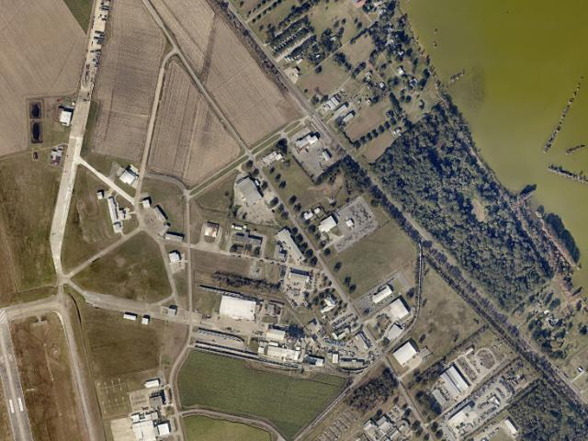
Aerial photo of the project location (2024 imagery).

What it is changing
The old roadway was only 24 feet wide with two sharp curves that created safety hazards. Crews repaved and realigned about a mile of road and replaced part of the grass median with concrete, making the route safer for airport traffic, Port of Iberia trucks, residents, and emergency vehicles.

Timeline / Completion Date
Project Status: Completed
Estimated Cost: $1,114,972 (about $1.1 million)
Funding Source: Coastal Impact Assistance Program (CIAP)

Port of Iberia Bridge Replacement – Port Road Over Commercial Canal (TV-0028)

Where it's at
This project is on Port Road in Iberia Parish, where it crosses Commercial Canal near the Port of Iberia.

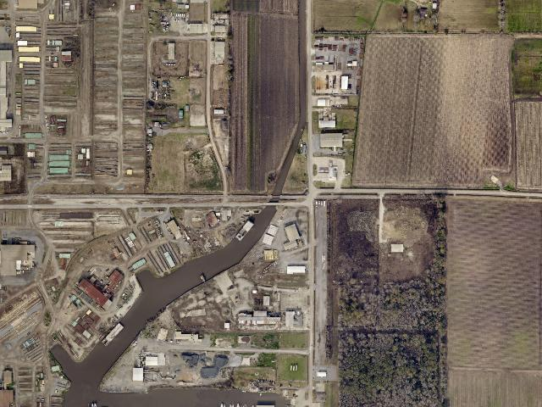
Aerial photo of the project location (2024 imagery).

What it is changing
The old bridge was a timber-and-precast structure in extremely poor condition. It was replaced with a new pre-cast concrete bridge built to safely carry the heavy daily traffic — employees, residents, and commercial trucks — that depends on this route to reach the Port of Iberia.

Timeline / Completion Date
Project Status: Completed
Estimated Cost: $625,792
Funding Source: Coastal Impact Assistance Program (CIAP)

Port of Iberia Bridge Replacement – David Dubois Road Over Commercial Canal (TV-0030)

Where it's at
This project is on David Dubois Road in Iberia Parish, where the road crosses Commercial Canal near the Port of Iberia.

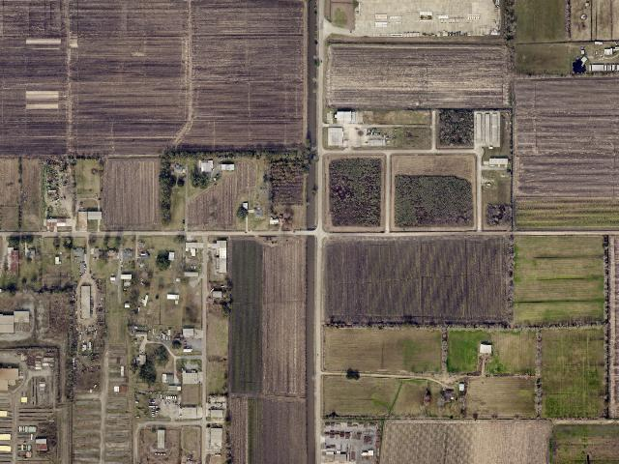
Aerial photo of the project location (2024 imagery).

What it is changing
Like its sister bridge on Port Road, the old timber-and-precast bridge here was wearing out. It was replaced with a new pre-cast concrete bridge able to handle the heavy truck and commuter traffic that keeps the Port of Iberia running, keeping the route safe for years to come.

Timeline / Completion Date
Project Status: Completed
Estimated Cost: $1,058,013 (about $1.1 million)
Funding Source: Coastal Impact Assistance Program (CIAP)

Rutton Rill Road Flood Protection (TV-0094)

Where it's at
This project is at Rutton Rill Road in Iberia Parish, in the low-lying Chenière Plain region.

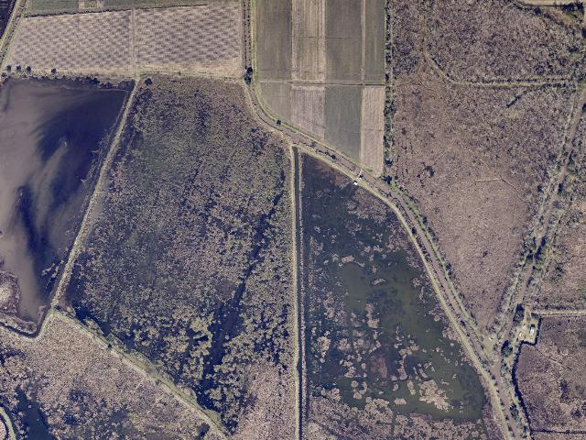
Aerial photo of the project location (2024 imagery).

What it is changing
Right now there is no structure to hold back tidal water at Rutton Rill Road, so high tides and storm surge can push water upstream and flood the area. CPRA is designing and building a water control structure that will hold back that tidal surge while still letting rainwater drain out after storms, reducing flooding for nearby homes, farmland, and wetlands.

Timeline / Completion Date
Project Status: Headed to Bid (the project is preparing to accept construction bids before work begins)
Estimated Cost: $3,928,864 (about $3.9 million)
Funding Source: State of Louisiana

Stumpy Bayou Flood Protection (TV-0095)

Where it's at
This project is at Stumpy Bayou in Iberia Parish and the low-lying wetlands around it.

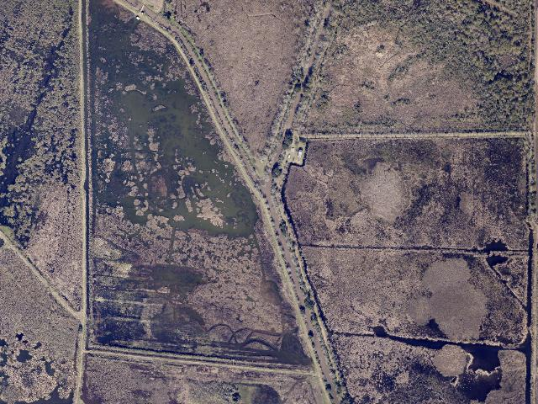
Aerial photo of the project location (2024 imagery).

What it is changing
Uncontrolled tidal water and storm runoff have been backing up into Stumpy Bayou, leaving upstream areas flooded for long stretches and letting salt water creep into fresh marsh. CPRA is engineering and building a water control structure to hold back the tide while still allowing rainwater to drain, cutting down on flooding for the surrounding community.

Timeline / Completion Date
Project Status: Headed to Bid (the project is preparing to accept construction bids before construction starts)
Estimated Cost: $8,415,526 (about $8.4 million)
Funding Source: State of Louisiana

CIAP Performance Evaluation Borrow Area Management and Monitoring (LA-0012-7)

Where it's at
This research project covers several “borrow areas” — sites where sediment was dug up to help build other restoration projects — across coastal Louisiana, including sites tied to Iberia Parish.

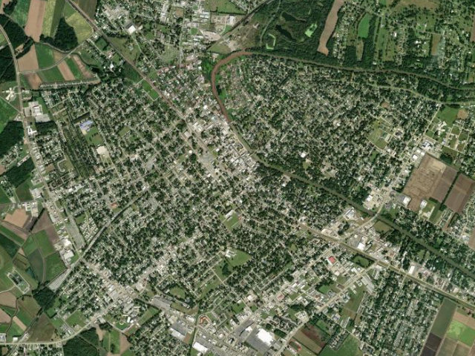
Aerial photo of the project location (2024 imagery).

What it is changing
When crews dig up sand and mud to rebuild marsh elsewhere, the resulting pits change over time. This project studied how those borrow pits fill back in and change shape, and whether the dredging affected water quality, so future restoration projects can be planned more responsibly.

Timeline / Completion Date
Project Status: Completed
Estimated Cost: $813,512, all state dollars
Funding Source: Coastal Impact Assistance Program (CIAP)

Non-Rock Alternatives to Shoreline Protection Demonstration (LA-0016)

Where it's at
This project is along the eastern shoreline of Vermilion Bay, on Shark Island in Iberia Parish.

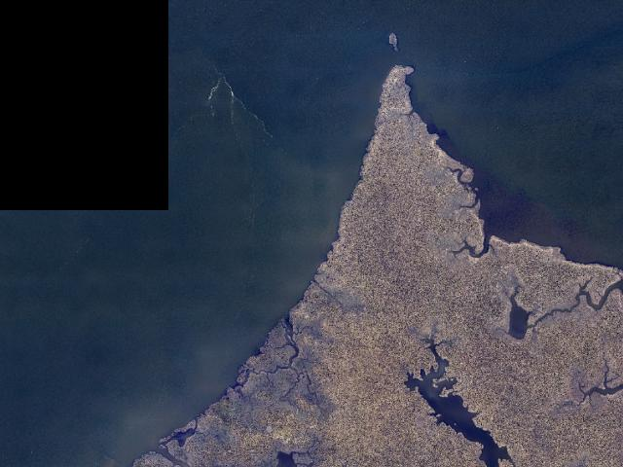
Aerial photo of the project location (2024 imagery).

What it is changing
Rock is the usual way to armor an eroding shoreline, but it does not work everywhere — some sites have soil too soft, or are too hard to reach, for standard rock revetments. This project tested several non-rock alternatives to protect the shoreline from erosion, with the results used to guide future coastal restoration choices statewide.

Timeline / Completion Date
Project Status: Completed
Estimated Cost: $7,358,699 ($916,305 in state dollars)
Funding Source: Coastal Wetlands Planning, Protection and Restoration Act (CWPPRA)

East Marsh Island Marsh Creation (TV-0021)

Where it's at
This project is at the east end of Marsh Island Wildlife Refuge, southeast of Lake Sand in Iberia Parish.

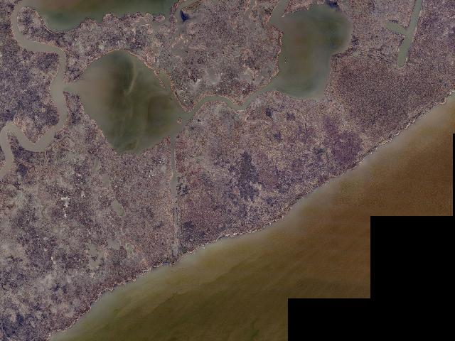
Aerial photo of the project location (2024 imagery).

What it is changing
Hurricane Lili in 2002 turned large stretches of interior marsh on Marsh Island into open water. Crews pumped in 3.8 million cubic yards of dredged sediment to rebuild about 362 acres of brackish marsh, then used leftover funds to create or nourish 500 more acres — restoring wildlife habitat and a storm buffer for the parish.

Timeline / Completion Date
Project Status: Completed
Estimated Cost: $21,215,936 ($3,404,633 in state dollars)
Funding Source: Coastal Wetlands Planning, Protection and Restoration Act (CWPPRA)

Cypremort Point State Park Improvements (TV-0081)

Where it's at
This project is at Cypremort Point State Park, about 1.5 miles northeast of Cypremort Point in Vermilion Bay, spanning St. Mary and Iberia Parishes.

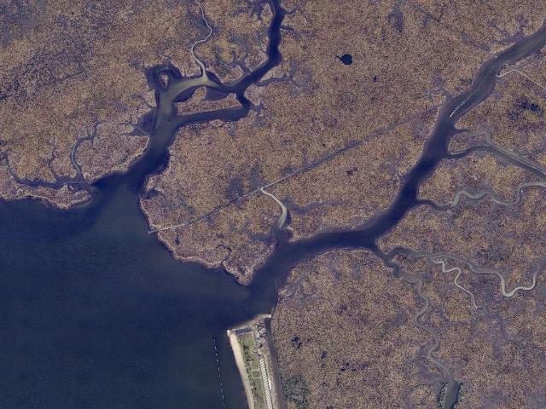
Aerial photo of the project location (2024 imagery).

What it is changing
Repeated flooding had damaged park roads and parking, and the rock jetty and public beach needed work. The project reinforced the Quintana Canal rock embankment, restored the public beach, built a new marsh boardwalk, repaired flood-damaged roads, and added an RV campground with up to 30 pull-through sites — expanding recreation and education opportunities for the community.

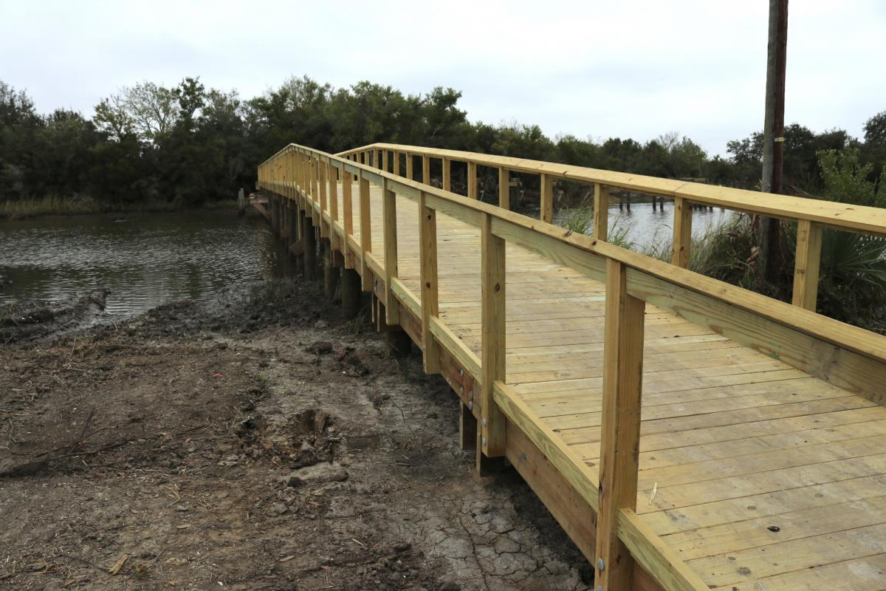
The new marsh boardwalk. Photo: Louisiana Office of Tourism, via iberiatravel.com — usage rights pending confirmation before public launch.

Timeline / Completion Date
Project Status: Completed
Estimated Cost: $5,577,338, all state dollars
Funding Source: Natural Resource Damage Assessment (NRDA)

Little Valley Bayou Water Control Structure (TV-0092)

Where it's at
This project is at Little Valley Bayou in Iberia Parish.

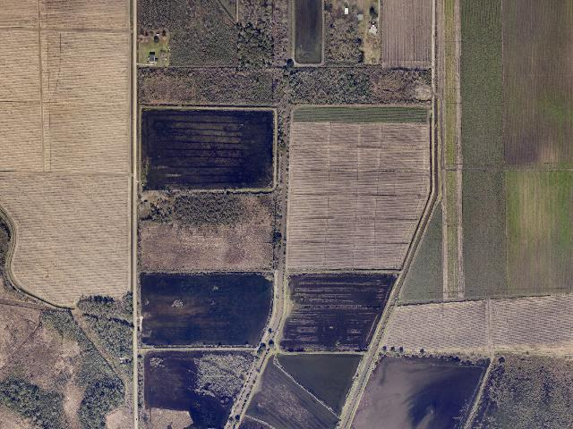
Aerial photo of the project location (2024 imagery).

What it is changing
Without a control structure, the bayou’s headwaters and nearby marshes take on unchecked tidal water, raising water levels upstream and increasing flood risk. CPRA is engineering, designing, and building a water control structure to regulate tidal and storm-surge intrusion while still letting rainwater drain freely, reducing flood risk for the surrounding community.

Timeline / Completion Date
Project Status: Headed to Bid (the project is preparing to accept construction bids)
Estimated Cost: $6,286,569
Funding Source: State of Louisiana

Iberia/St. Mary Upland Levee (TV-0102)

Where it's at
This project spans Iberia and St. Mary Parishes, between the Delcambre Canal and the Charenton Canal.

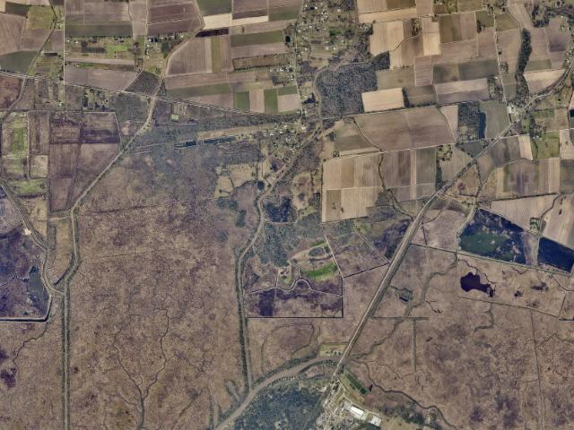
Aerial photo of the project location (2024 imagery).

What it is changing
Low-lying communities along this corridor face growing risk from storm surge and tidal flooding with no engineered barrier to stop it. This large-scale project is designing an earthen levee system — with T-walls, barge gates, and pump stations — to protect roughly 140,000 acres and reduce flood damage for homes and businesses in both parishes.

Timeline / Completion Date
Project Status: In Engineering & Design
Estimated Cost: $15,000,000
Funding Source: Gulf of Mexico Energy Security Act (GOMESA)

Big Bayou Pigeon Depth Restoration (AT-0039)

Where it's at
This project is at Big Bayou Pigeon, along the Iberia–Iberville parish line.

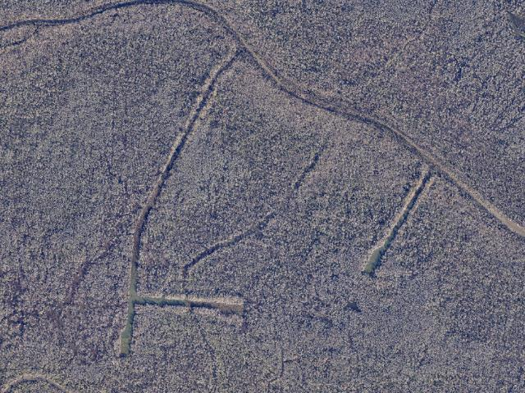
Aerial photo of the project location (2024 imagery).

What it is changing
CPRA has not yet published a detailed public description of this project’s design. It is currently in the engineering and design phase; check CPRA’s Coastal Information Management System (CIMS) for the latest project status as more information becomes available.

Timeline / Completion Date
Project Status: In Engineering & Design
Estimated Cost: $500,000
Funding Source: State of Louisiana

Abbeville and Vicinity Hurricane Protection (TV-0108)

Where it's at
This project covers the area south of Delcambre, Erath, and Abbeville, roughly following Highway 330 (Vermilion and Iberia Parishes).

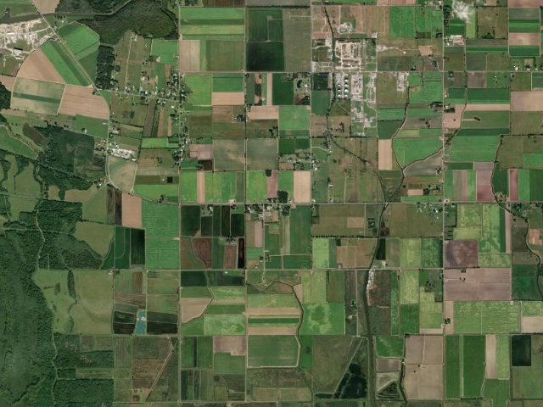
Aerial photo of the project location (2024 imagery, satellite imagery for this one site).

What it is changing
Communities in this low-lying corridor face growing storm surge risk. CPRA’s long-range 2023 Coastal Master Plan envisions a levee here reaching 15.5 to 20 feet in elevation, with earthen levee, T-wall, and gated sections, to reduce flood risk for the community. This project is still in early planning; the master plan figures describe the long-term concept, not a finalized design.

Timeline / Completion Date
Project Status: In Planning
Estimated Cost: $1,100,000
Funding Source: Gulf of Mexico Energy Security Act (GOMESA)

